

Instituto Politécnico Nacional
Escuela Superior de Computo

Materia: Bases de Datos
Profesor: Iván Diaz Toala
Equipo:
Oswaldo Gil Valentín
Rojas Tapia Italuu
Godínez Pérez Karla
Grupo: 3CV4 Fecha: 10/12/2023
Actividad: Reporte Practica 4



Descripción:
Un convertidor de binario a 7 segmentos es un circuito lógico utilizado para convertir un número binario (normalmente de 4 bits, representando números del 0 al 15) en una señal adecuada para mostrarlo en un display de 7 segmentos.
Cálculos de diseño:
N | A | B | C | D | a | b | c | d | e | f | g
0 | 0 | 0 | 0 | 0 | 1 | 1 | 1 | 1 | 1 | 1 | 0
1 | 0 | 0 | 0 | 1 | 0 | 1 | 1 | 0 | 0 | 0 | 0
2 | 0 | 0 | 1 | 0 | 1 | 1 | 0 | 1 | 1 | 0 | 1
3 | 0 | 0 | 1 | 1 | 1 | 1 | 1 | 1 | 0 | 0 | 1
4 | 0 | 1 | 0 | 0 | 0 | 1 | 1 | 0 | 0 | 1 | 1
5 | 0 | 1 | 0 | 1 | 1 | 0 | 1 | 1 | 0 | 1 | 1
6 | 0 | 1 | 1 | 0 | 1 | 0 | 1 | 1 | 1 | 1 | 1
7 | 0 | 1 | 1 | 1 | 1 | 1 | 1 | 0 | 0 | 0 | 0
8 | 1 | 0 | 0 | 0 | 1 | 1 | 1 | 1 | 1 | 1 | 1
9 | 1 | 0 | 0 | 1 | 1 | 1 | 1 | 0 | 0 | 1 | 1
10 | 1 | 0 | 1 | 0 | 1 | 1 | 1 | 0 | 1 | 1 | 1
11 | 1 | 0 | 1 | 1 | 0 | 0 | 1 | 1 | 1 | 1 | 1
12 | 1 | 1 | 0 | 0 | 1 | 0 | 0 | 1 | 1 | 1 | 0
13 | 1 | 1 | 0 | 1 | 0 | 1 | 1 | 1 | 1 | 0 | 1
14 | 1 | 1 | 1 | 0 | 1 | 0 | 0 | 1 | 1 | 1 | 1
15 | 1 | 1 | 1 | 1 | 1 | 0 | 0 | 0 | 1 | 1 | 1

a(A,B,C,D)∑(0,2,3,5-10,12,14,15)
b(A,B,C,D)∑(0-4,7-10,13)
c(A,B,C,D)∑(0,1,3-11,13)
d(A,B,C,D)∑(0,2,3,5,6,8,11-14)
e(A,B,C,D)∑(0,2,6,8,10-15)
f(A,B,C,D)∑(0,4-6,8-12,14,15)
g(A,B,C,D)∑(2-6,8-11,13-15)

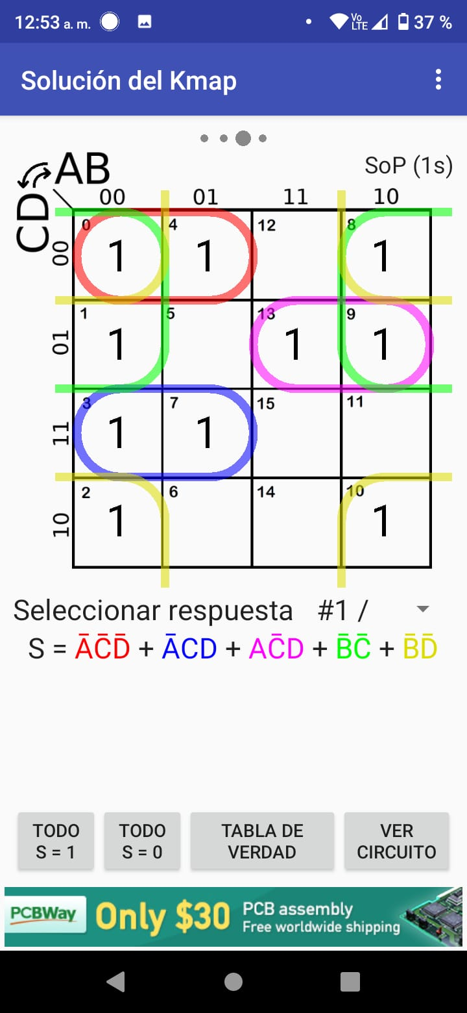
a(A,B,C,D)∑(0,2,3,5-10,12,14,15) b(A,B,C,D)∑(0-4,7-10,13)
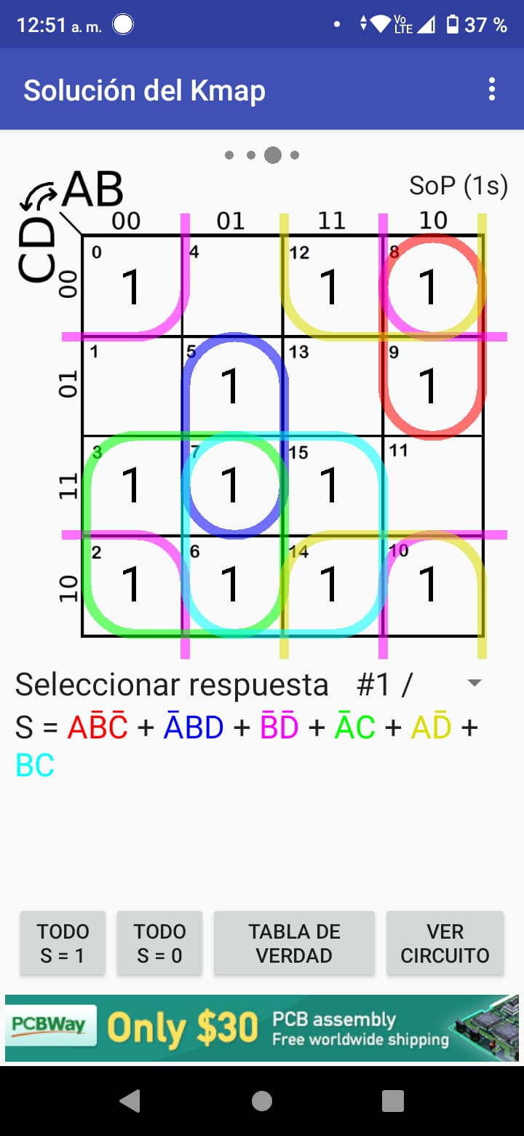

c(A,B,C,D)∑(0,1,3-11,13) d(A,B,C,D)∑(0,2,3,5,6,8,11-14)
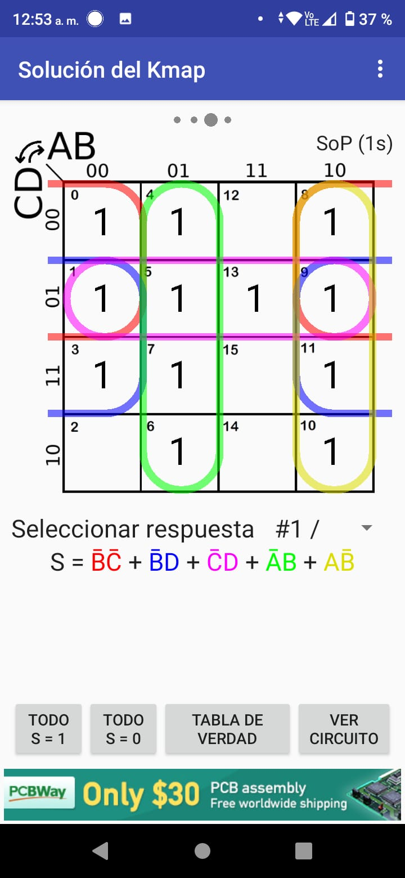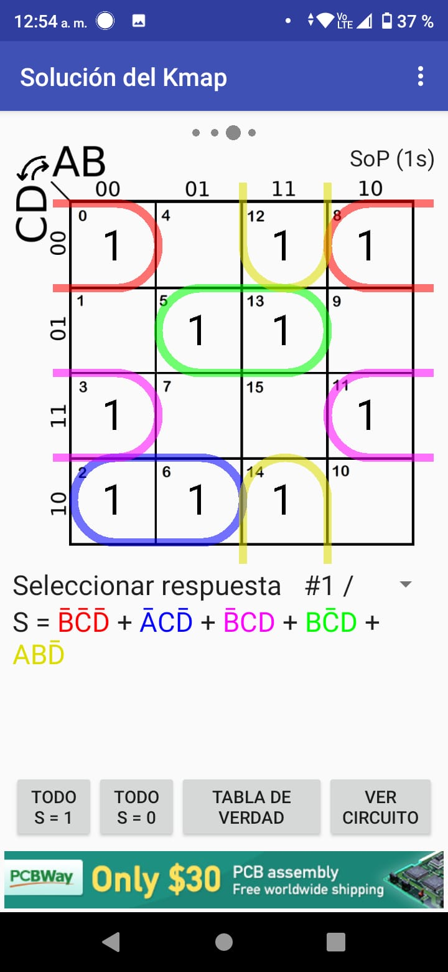

e(A,B,C,D)∑(0,2,6,8,10-15) f(A,B,C,D)∑(0,4-6,8-12,14,15)
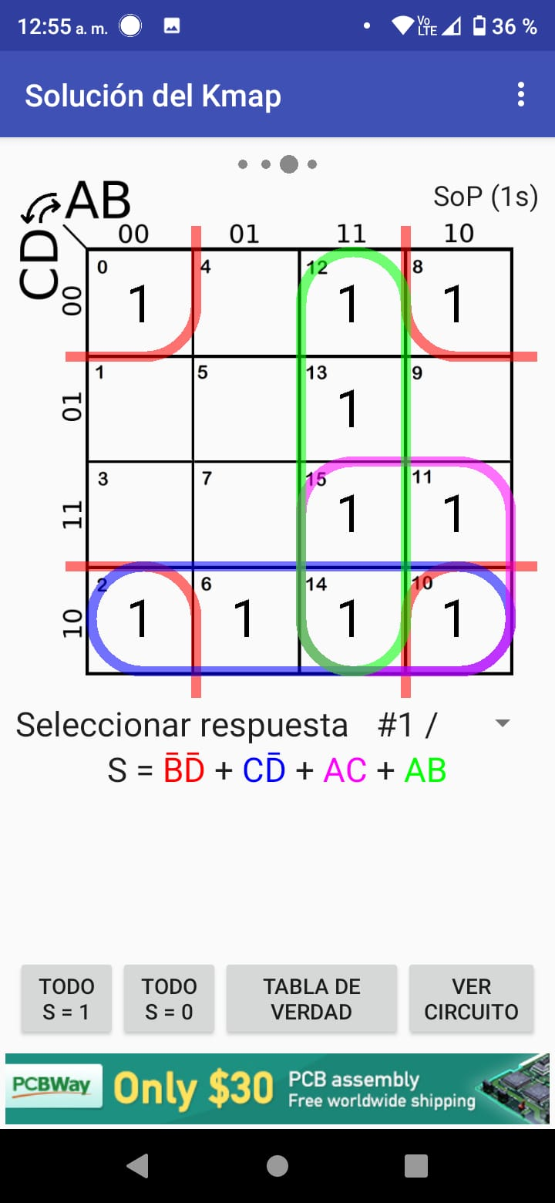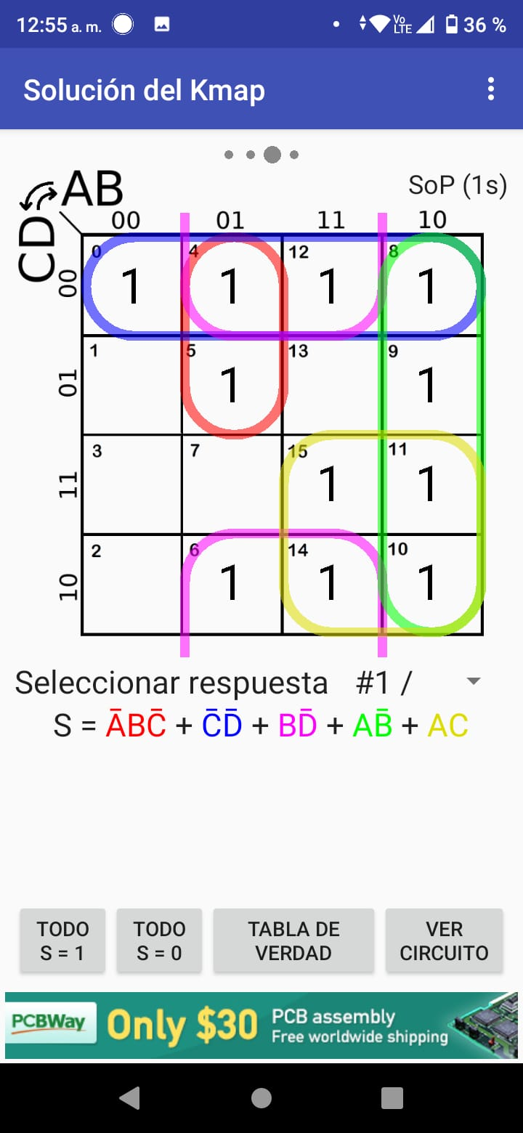

g(A,B,C,D)∑(2-6,8-11,13-15)
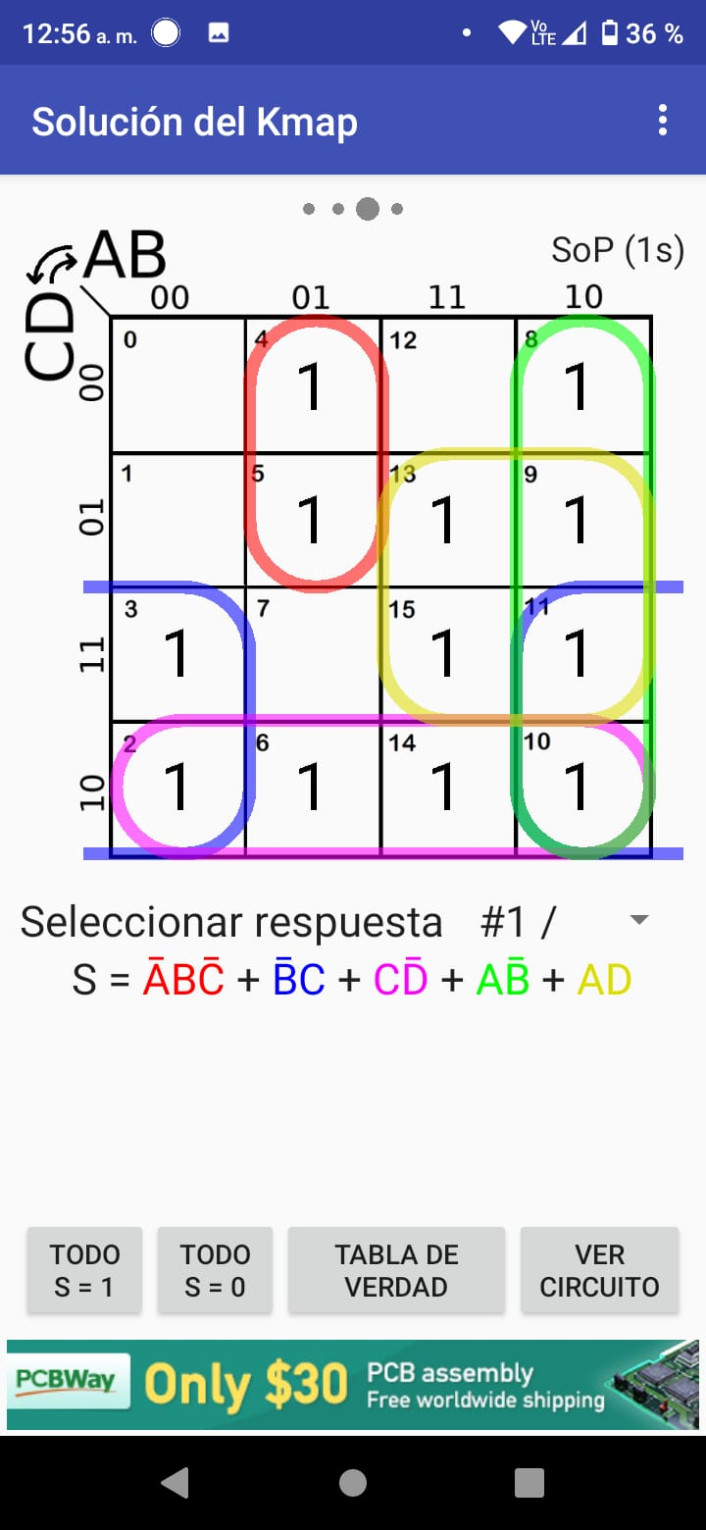

Código VHDL:
library ieee;
use ieee.std_logic_1164.all;

entity BIN7SEG is
port(A, B, C, D: in std_logic;
F1: out std_logic;
F2: out std_logic;
F3: out std_logic;
F4: out std_logic;
F5: out std_logic;
F6: out std_logic;
F7: out std_logic);
end BIN7SEG;

architecture BIN7SEG of BIN7SEG is begin
F1 <=((NOT B) AND (NOT D)) OR (B AND C) OR ((NOT A) AND C) OR ((NOT A) AND B AND D) OR (A AND (NOT B) AND (NOT C)) OR (A AND (NOT C) AND (NOT D));
F2 <= ((NOT B) AND (NOT D)) OR ((NOT B) AND (NOT C)) OR (A AND (NOT C) AND D) OR ((NOT A) AND (NOT C) AND (NOT D)) OR ((NOT A) AND C AND D) OR ((NOT A) AND (NOT B));
F3 <=(A AND (NOT B)) OR ((NOT A) AND B) OR ((NOT C) AND D) OR ((NOT A) AND (NOT C)) OR ((NOT A) AND D);
F4 <=((NOT B) AND (NOT C) AND (NOT D)) OR (A AND B AND (NOT C)) OR (B AND (NOT C) AND D) OR ((NOT A) AND (NOT B) AND C) OR ((NOT B) AND C AND D) OR (B AND C AND (NOT D));
F5 <=((NOT B) AND (NOT D)) OR (A AND B) OR (C AND (NOT D)) OR (A AND C);
F6 <=(A AND (NOT B)) OR (A AND C) OR ((NOT C) AND (NOT D)) OR (B AND (NOT D)) OR (A AND B AND (NOT C));
F7 <=((NOT A) AND B AND (NOT C)) OR (A AND (NOT B)) OR (C AND (NOT D)) OR (A AND D) OR ((NOT B) AND C);
end BIN7SEG;

Evidencias de prueba del circuito (fotografías de circuito y su funcionamiento): 